***GROUP A26***

***PUSL2021-COMPUTING GROUP PROJECT***

***Final Project Report***

“EASY BUS” Online Bus Booking & Tracking Mobile Application

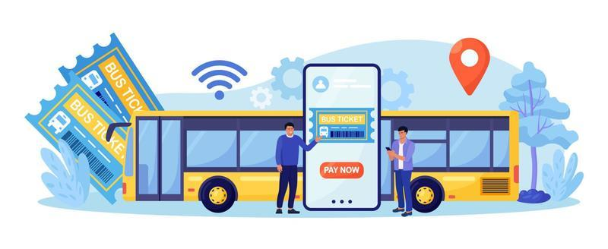

|  |
| --- |
| Name: Wedamulla Madusanka |
| Student Reference Number:10899603 |



|  |  |  |
| --- | --- | --- |
| Module Code: PUSL2021 | Module Name: Computing group project | |
| Coursework Title: Final Report Submission | | |
| Deadline Date: 20/04/2024 | | Member of staff responsible for coursework: Dr Chaminda Wijesinghe |
| Programme: BSc (Hons)Software Engineering | | |
| Please note that University Academic Regulations are available under Rules and Regulations on the University website [www.plymouth.ac.uk/studenthandbook](http://www.plymouth.ac.uk/studenthandbook). | | |
| Group work: please list all names of all participants formally associated with this work and state whether the work was undertaken alone or as part of a team. Please note you may be required to identify individual responsibility for component parts.  ***We confirm that we have read and understood the Plymouth University regulations relating to Assessment Offences and that we are aware of the possible penalties for any breach of these regulations. We confirm that this is the independent work of the group.***  10899603- Wedamulla Madinage Thisara Madusanka  10899521- Navindu Nimsara Gamage  10899621- Chathupraba Devindi Munasinghe  10899556- Yaddehi Kishal Sankalpa Jayalath  10899685- Kihaduwage Diduli Wijini Sahasra  10899600- Senanayake Dasili Liyanage Sameepa Pramuditha  Signed on behalf of the group: | | |
| Individual assignment: ***I confirm that I have read and understood the Plymouth University regulations relating to Assessment Offences and that I am aware of the possible penalties for any breach of these regulations. I confirm that this is my own independent work.***  Signed: | | |
| Use of translation software: failure to declare that translation software or a similar writing aid has been used will be treated as an assessment offence.  I *have used/not used translation software.  If used, please state name of software………………………………………………………………… | | |
| **Overall mark _____% Assessors Initials ______ Date_________** | | |

*

**Abstract**

The goal of this project is to create a mobile application that will speed up bus seat reservations and tracking processes in Sri Lanka. The primary objectives were to improve the user experience, boost the operational efficiency of bus operators, and provide real-time bus tracking and seat reservation capabilities.

To achieve these objectives, a mix of user interviews, observations, and surveys was used to collect data on user preferences and pain points. In addition, existing records were reviewed to improve the data collection process. The Flutter framework and the Dart programming language were used to create the system, and dependencies were added to enhance features like local database management and Google Maps integration.

Notable results include the successful development of an easy-to-use mobile application that enables users to plan bus routes, track the location of buses in real-time, and make seat reservations fast. The system architecture was designed to ensure scalability and stability, and it is distributed to app stores to enable widespread accessibility.

In summary, the project provides a feasible solution to the ineffective bus seat reservation and monitoring problem in Sri Lanka. However, limitations like reliance on network connectivity and other security concerns should be addressed by future generations. Suggestions include making even more improvements to the user interface and monitoring user feedback to ensure ongoing progress.

Table of Contents

Introduction 5

Overview of the Project 5

Purpose of the project 5

Justification for the project 6

Scope and objectives 6

Background. 7

It is essential to comprehend the theoretical foundations and empirical research findings in this area. 7

Literature study 8

Theoretical Framework for the Solution 9

User requirement 10

Users (Stakeholders): 10

Fact Gathering 10

Use Case Analysis. 11

Persona Development 12

Requirements Prioritization 12

Functional Requirements: 13

Non-Functional Requirements: 13

Verification and Validation of Findings: 13

Functional Specifications 14

Functional Requirement ID: RTB-001 14

Functional Requirement ID: RTB-002 14

Functional Requirement ID: RTB-003 14

Functional Requirement ID: RTB-004 15

Functional Requirement ID: RTB-005 15

Functional Requirement ID: RTB-006 16

Functional Requirement ID: RTB-007 16

Functional Requirement ID: RTB-008 16

Technical Specification 17

User Interface Design- UI and UX. 17

Firebase Firestore Database Tables 20

Data Model 23

System Architecture 23

Deployment and Infrastructure 24

Testing Strategy 24

Dependencies 24

Work breakdown. 26

Project Phases: 26

Work Breakdown Structure (WBS) 27

Timeline: 28

Gnatt chart 29

Critical Path & total time duration. 29

The total time duration for completing the critical path tasks is: 29

Resource Allocation 29

Milestones alien with deliverables. 31

Results and Discussion 32

Discussion on Achievements 32

Test Cases/Test Results Summary 33

Findings and rectifications suggested /applied 35

Future improvements and development path 35

Appendix 36

Individual contribution Metrix 36

User requirement gathering data 38

References 47

GitHub Link 47

Conclusion 49

# Introduction

# Overview of the Project

Our project, "Easy BUS-The Digital Bus Tracking and Reservation Platform," is a smartphone application that we hope will revolutionize and revive the bus transportation sector. Having acknowledged Sri Lanka's current status and its vital role in social development, we have decided to concentrate only on intercity bus services. Because obtaining tickets for highway bus routes is a deeply ingrained traditional habit, there are currently long lines at bus stations before departure. Therefore, there is an urgent need for a cutting-edge solution that offers expedited ticket procurement and real-time bus status updates in order to meet the exacting expectations of customers.

This technology will drastically change bus booking and tracking while also greatly increasing the convenience, effectiveness, and usefulness of buses. The project's goal is to improve the overall experience by integrating safe payment methods, user-friendly interfaces, and real-time tracking for both bus drivers and passengers. Even though transportation companies have moved from a manual to an automated approach for managing the data of their drivers and passengers in the booking and tracking areas, some adjustments still need to be made. One of these upgrades is a feature that allows users to follow the whereabouts of the reserved bus, as well as its arrival and departure times and whether the route trip has been canceled.

In a fast-paced setting where accessibility and convenience are crucial, modern commuters have high expectations, and traditional bus seat reservation techniques frequently fall short of meeting those expectations. By introducing a clever mobile application made especially for bus seat reservations, the suggested concept seeks to transform this aspect of transportation. This software will function as a digital gateway, connecting passengers with available seats on various bus routes with the ease of a smartphone.

## Purpose of the project

Closing the gap between the antiquated bus seat reservation processes and the changing needs of contemporary travelers is the main objective of this project. The project intends to eliminate the logistical challenges associated with traditional booking methods by using mobile technology, turning a tedious process into a straightforward and easy experience. Through this effort, the initiative hopes to rethink and improve the bus seat reservation paradigm, making it more efficient and user-friendly.

## Justification for the project

From a strategic standpoint, the initiative is a proactive response to the shifting landscape of the transportation sector. By making an investment in a mobile application for bus seat booking, bus operators can increase the effectiveness of their operations and solidify their position in a fiercely competitive market. In addition, the idea has the potential to advance accessibility and inclusion in society by providing commuters from a variety of backgrounds with unparalleled comfort and convenience.

The project also tackles the need for safe and convenient transportation options in society, especially in rural and urban areas where public transportation is essential for fostering a sense of community. The program employs technology to increase accessibility and dependability of bus services, reduce traffic, and promote environmentally friendly transportation methods.

## Scope and objectives

Scope:

The project's scope is broad; it includes everything from developing a feature-rich mobile application to seamlessly integrating it with bus management systems that are currently in use. This comprises the following:

* Extensive Feature Set: The mobile application offers a wide range of features, including real-time seat availability, safe payment methods, route research, and personalized booking options.
* Sophisticated interaction: By ensuring real-time data synchronization through seamless interaction with backend bus management systems, operators can efficiently manage reservations and enhance seat allocation.
* Robust Testing Regimen: Implementing a rigorous testing schedule to ensure the program's dependability, security, and usability across a range of user scenarios and operating environments.
* Strategic Deployment: Use targeted marketing strategies in conjunction with a strategic distribution of the application across the primary app distribution channels to maximize the number of users and engagement.

Objectives:

The project's many goals are designed to further the primary objective of streamlining the bus seat reservation process while also offering genuine advantages to interested parties. These objectives include:

* User-Centric Design: Booking is made easy for users of all demographics by offering a user-centric mobile application that prioritizes accessibility, ease of use, and intuitiveness.
* Operational Efficiency: Bus operators can increase their operational efficiency by increasing seat usage, automating crucial tasks, and offering real-time insights into customer preferences and booking patterns.
* Customer Delight: promoting an environment where users' opinions are actively sought after, problems are fixed right away, and the program is constantly improved to go above and beyond what users could ever hope for.
* Income Growth: Bus operators can boost revenue growth by implementing strategies such as expanding their clientele, enhancing value-added services and partnerships, and boosting booking frequency.
* Market Leadership: establishing the mobile application as the preferred method for bus seat reservations in the target market, thereby solidifying the brand's leadership position in digital transportation solutions.

By defining a clear scope and setting realistic yet challenging objectives, the project opens the door for revolutionary innovation in the bus seat reservation market, which is anticipated to have a significant impact on the transportation environment.

# Background.

As digital technology has expanded and the demand for convenient transportation options has increased, online bus booking and tracking systems have grown in popularity. Conventional bus ticket purchasing and route tracking systems often have lengthy lineups, manual processes, and a lack of real-time bus position visibility. These features are inefficient and annoying for both customers and service providers.

Online booking and bus monitoring systems have the potential to revolutionize public transportation and enable sustainable mobility solutions in both urban and rural environments by driving operational effectiveness, improving the overall passenger experience, and streamlining the booking process. Consequently, in order to develop efficient, user-centric solutions that satisfy the changing needs of service providers and customers alike,

## It is essential to comprehend the theoretical foundations and empirical research findings in this area.

## Literature study

Summary of Current Research:

There has been a great deal of research on seat reservation systems and bus tracking, albeit with varying goals and methodologies. Technological developments in transportation have been examined, including the use of smartphone applications, GPS tracking, and online booking platforms. Studies have also examined the impact of these technologies on the transportation sector's capacity to enhance user experience, maximize resource utilization, and boost operational effectiveness.

Current Products or Solutions:

There are currently a wide range of goods and services on the market, ranging from standalone bus tracking applications to comprehensive bus management platforms. These solutions come with features like secure payment processing, real-time bus tracking, seat reservations, and route planning. Among the notable instances are:

a) Google Maps Transit:users to plan their routes and view real-time arrival times and bus schedules.

b) Moovit: Offers a feature-rich public transportation app with route planning, bus monitoring, and real-time arrival and departure bus updates.

c) BusBud: An online resource where customers can check bus schedules, compare costs, and buy tickets.

Evaluation of Advantages and Disadvantages:

**Advantages:**

• Improved Accessibility: Passengers can easily view bus timetables, track the location of buses, and reserve seats from the comfort of their smartphones.

• Enhanced Efficiency: Real-time tracking and optimization algorithms enable the reduction of waiting times, the ease of traffic, and the overall operational efficiency.

• Better User Experience: Using user-friendly interfaces and efficient booking processes results in a more positive experience for passengers.

**Disadvantages:**

• Technology Dependency: Reliance on GPS signals and mobile networks may lead to service disruptions or erroneous bus tracking data.

• Connectivity issues: Individuals may experience difficulty completing online reservations or obtaining real-time information in locations with sporadic network connections.

• Security Problems: Online transactions and personal information stored on the system could be vulnerable to cybersecurity attacks if it is not properly secured.

## Theoretical Framework for the Solution

Theories at the Development/Design Level Involved:

* 1. User-Centered Design (UCD): The project makes use of UCD principles to ensure that the mobile application is developed with the end user in mind. The app prioritizes usability, accessibility, and user satisfaction in order to deliver a seamless and easy booking process.
  2. Information Systems Theory: Information systems theory, which emphasizes the value of data management, information flow, and system interoperability, is followed in the design and implementation of the bus tracking and booking system. By applying this theoretical framework, the research aims to develop a scalable and dependable system that can handle large volumes of data and facilitate seamless communication between various components.
  3. Users' attitudes about how to accept and use new technology are provided by the Technology Acceptance Model, or TAM. The project aims to ensure that the mobile application meets the needs and expectations of its target customers by identifying and overcoming potential adoption hurdles through the integration of TAM aspects into the design process.
  4. Agile development technique: This technique facilitates rapid prototyping, continuous feedback, and iterative development. The project team can promptly address changing needs and stakeholder feedback because this method allows for flexibility and adaptation throughout the development process.

Justification:

• UCD ensures that the application is user-friendly and meets the needs of the target audience, thereby boosting user satisfaction and adoption.

•Information systems theory provides a foundation for developing a scalable, interoperable system that can effectively manage bus tracking and booking data.

• TAM helps identify factors influencing user acceptability and adoption, which in turn directs the design process to maximize usability and reduce resistance to change.

• Agile development ensures that the application adapts to its stakeholders' and users' changing needs, allowing the project team to iteratively improve the application based on user feedback.

# User requirement

Users (Stakeholders):

* Passengers: The main users of the bus tracking and reservation app are those who use it to find routes, reserve seats, and monitor the location of buses.
* Bus operators: These are the individuals responsible for overseeing the fleet, scheduling, and day-to-day operations of buses. To keep an eye on bus performance, figure out the best routes, and interact with passengers, they need the right equipment.
* Administrators: They are in charge of managing user accounts, keeping an eye on the overall functionality of the online booking platform, and guaranteeing the security and dependability of the system.

Fact Gathering

Questionnaires:

Stakeholders, bus operators, and commuters in Sri Lanka were sent structured questionnaires to gather data on preferences, issues, and behaviors related to bus transportation.

Observations:

thorough observations conducted during bus rides and at bus stops to get a firsthand understanding of user interactions, behavior, and experiences. Important contextual information is also provided by these observations.

Current Documents Searching:

selecting relevant data and insights about bus travel in Sri Lanka by going over the papers, research, and documentation that are currently available from governmental organizations, transportation authorities, and academic institutions.

Ex:

* MMC Kottawa Website : <https://www.mmck.lk/index-en.html>
* Article about Mobile Application for Smart Intercity Bus Tracking and Booking System in Sri Lanka by Nivesh Wanninayaka
* NTC Website : <https://www.ntc.gov.lk/Bus_info/time_table.php>

## Use Case Analysis.

## Persona Development

The process of designing and developing any product, including the Online Bus Tracking and Booking Mobile Application, must include the creation of personas. Personas are made-up characters designed to represent various user groups according to their behavioral, psychographic, and demographic traits. They help teams create user-centered solutions by assisting them in comprehending the requirements and preferences of users. Below is a summary of the steps involved in developing personas for the bus reservation and tracking app:

* Identify User Segments: Select the specific user segments that will initially use the program the most. Passengers, tourists, business travelers, students, and other groups of people can all be served by a bus tracking and reservation software.
* Obtain User Information: To learn about user demographics, preferences, and pain points, gather data through surveys, interviews, market research, and analytics.
* Create Persona Profiles: Using the gathered data, create persona profiles that correspond to various user categories. Personal information like name, age, profession, objectives, driving forces, difficulties, preferences, and actions connected to using the bus booking and tracking app should all be included in a persona.
* In order to create persona scenarios, outline common use cases or scenarios where each persona would communicate with the software. A few examples of these include purchasing a ticket, boarding the bus, making the payment, consulting the schedule, and getting alerts.
* Verify and repeat: To get input and confirmation, distribute the persona profiles to relevant parties such as product managers, designers, and developers. Rewrite the personalities of the characters based on the information acquired during the validation procedure.
* Update Often: Review and modify persona profiles on a regular basis in response to user feedback, shifts in industry trends, and modifications to user requirements. Updates to the persona make sure the application is always up to date and user-focused.

## Requirements Prioritization

Requirements prioritization is a crucial stage in the software development process that involves ranking features and functionalities based on their value, significance, and impact on the project's objectives. Setting needs in order of importance expedites development, guarantees that users receive the most important features first, and facilitates resource allocation. An approach to ranking requirements that is generally used is as follows:

* Assemble Requirements
* Understand Stakeholder Needs
* Define Evaluation Criteria
* Apply Prioritization Techniques
* Facilitate Collaborative Decision-making
* Iterate and Refine
* Document and Communicate
* Monitor and Adjust

## Functional Requirements:

These specify the desired functionality of the bus tracking and booking system, including features such as:

* User registration and login
* Route search and selection
* Seat selection and booking
* Real-time bus tracking
* Payment processing
* Notification alerts

## Non-Functional Requirements:

These define the quality attributes and constraints of the system, including:

* Performance: Response times, scalability, and reliability of the system.
* Security: Data encryption, secure authentication mechanisms, and compliance with data protection regulations.
* Usability: Intuitive user interface, accessibility features, and support for multiple devices and platforms.

## Verification and Validation of Findings:

Results will be validated through cross-referencing data from observations, surveys, user interviews, and use case analysis to ensure reliability and consistency. Project goals and stakeholder expectations will be taken into consideration when reviewing requirements to ensure alignment. Prototypes and mockups may be created to validate design decisions and gather user feedback prior to proceeding with development. Frequent validation and verification checkpoints will also help ensure that, at every stage of the development lifecycle, the final product meets user needs and effectively delivers value.

# Functional Specifications

## Functional Requirement ID: RTB-001

Requirement Description: An email address, full name, and password must be required in order for users to create an account on the bus tracking and booking online system.

Dependencies: None

Acceptance Criteria:

• From the system homepage, users ought to be able to reach the registration page.

• Users should receive a confirmation email to confirm their email address after registering.

• Users ought to be able to access their accounts by entering their password and registered email address.

Priority: High

## Functional Requirement ID: RTB-002

Requirement Description: It should be possible for users to look up bus routes according to their preferred travel dates, origin, and destination.

Dependencies: None

Acceptance Criteria:

• The homepage should have a search bar that is easily visible to users.

• Based on user input, autocomplete suggestions should be supported by the search functionality.

• Search results should be filterable by bus operator, arrival time, and departure time for users.

Priority: High

## Functional Requirement ID: RTB-003

Requirement Description: Access to comprehensive information on bus routes that are currently available, including bus operators, departure and arrival times, and ticket pricing, must be provided to users.   
Depending on: Functionality for searching RTB-002   
  
• A clear and well-organized list of search results should be presented to users, according to the acceptance criteria.   
• Relevant information regarding the bus route should be provided by each search result.   
It should be possible for users to examine more information by clicking on a certain route.   
  
Priority: Very High

## Functional Requirement ID: RTB-004

Requirement description: When purchasing bus tickets, customers should have the option to choose the seats of their choice.   
Dependencies: nonexistent  
Acceptance standards

* After selecting a particular bus route, users should be presented with an interface for selecting a seat, along with the cost of each seat.
* If necessary, users ought to be allowed to choose from a variety of chairs.   
    
  Middle-level Priority

## Functional Requirement ID: RTB-005

Using a variety of payment options, including credit/debit cards, mobile wallets, and internet banking, users must be able to safely purchase the tickets they have reserved.   
Depending on: Seat selection for RTB-004  
Standards of Acceptance:

* Upon verifying their seat selections, users should be redirected to a secure payment gateway that offers a variety of payment methods and clear directions on how to finish the transaction.
* As soon as the money is successfully processed, users ought to receive an email including their ticket details.   
    
  Priority: Very High

## Functional Requirement ID: RTB-006

The capability for users to follow the whereabouts of buses they have reserved in real time is described as a requirement.   
There are no dependencies.  
Recognition standards:   
  
The account dashboard should include a "Track My Bus" option available to users.   
In addition to the predicted arrival timings, the tracking interface need should provide the bus's present location on a map.

* Notice of any major delays or modifications to the route should be sent to users.   
    
  Priority: Very High

## Functional Requirement ID: RTB-007

The requirement description states that users must be able to contact customer service with any questions, concerns, or comments they may have regarding their reservations.

Dependencies: Not present

Gratitude Requirements:

* The system's navigation menu should provide users with access to a "Contact Us" or "Support" area.
* A knowledge base, email support, and live chat should all be available through the support system.
* Inquiries from users should be promptly answered, and they should be able to escalate problems if necessary.   
    
  Medium-level priority

## Functional Requirement ID: RTB-008

The capacity to handle user accounts, keep an eye on system performance, and provide data on booking patterns and income is a requirement description for administrators.   
Dependencies: Nothing  
Acceptance standards:   
  
• An admin panel that is safe and has programmable user roles and permissions should be available to administrators.   
• Features for checking booking data, changing passwords, and managing user accounts should be available in the admin panel.   
• Key performance indicators including booking volume, income, and user demographics should be able to be reported on by administrators.   
Priority: Very high

# Technical Specification

## User Interface Design- UI and UX.

The design strategy was focused on creating an intuitive and visually appealing user experience using Figma. It was vital to wireframe, prototype, and iterate on designs in order to ensure that users engaging with the mobile application could navigate the app simply and efficiently.

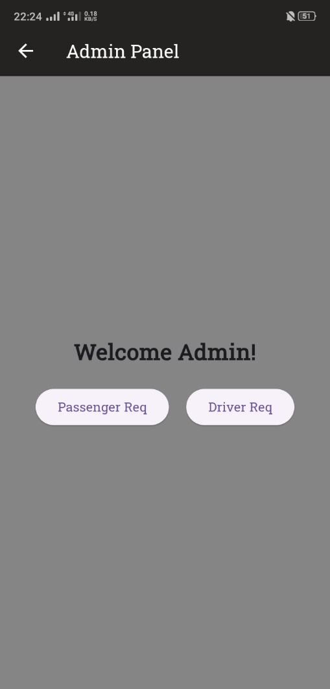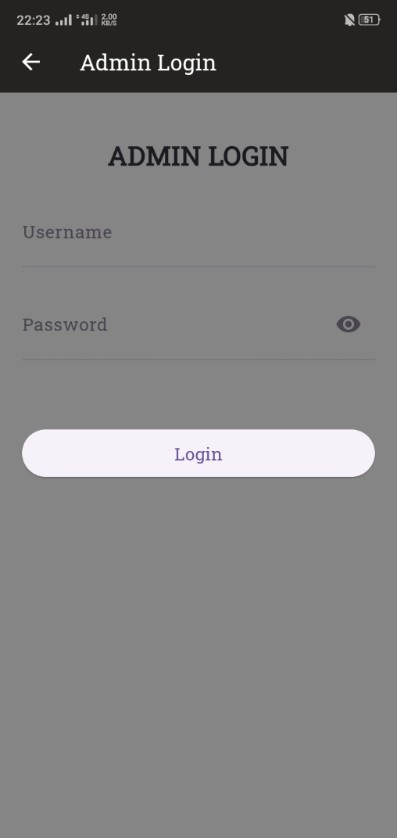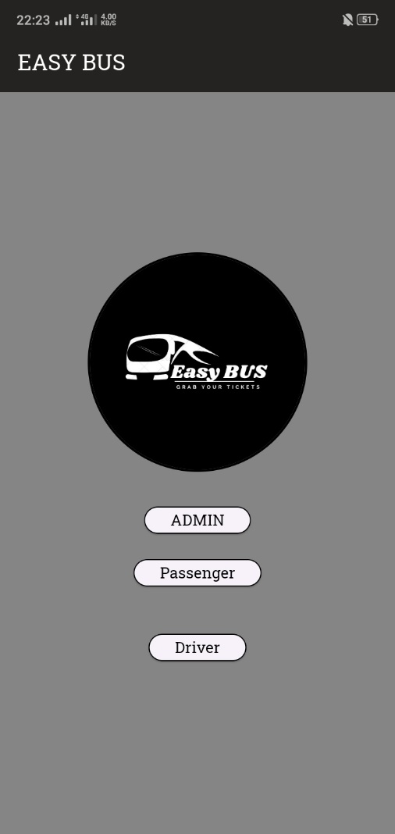

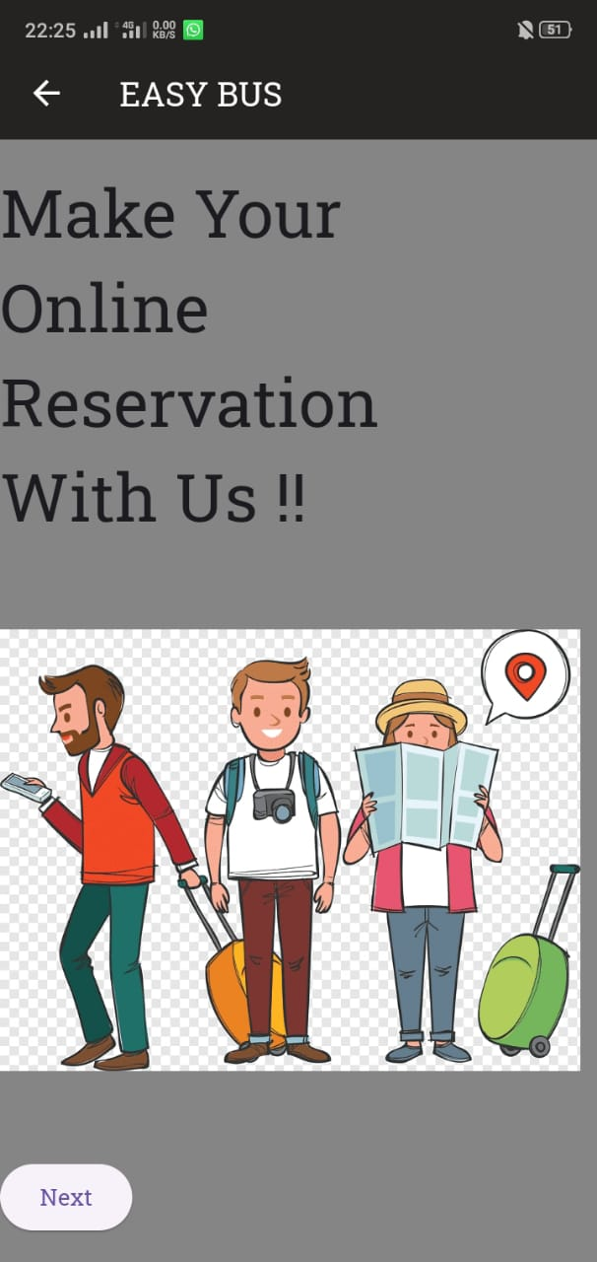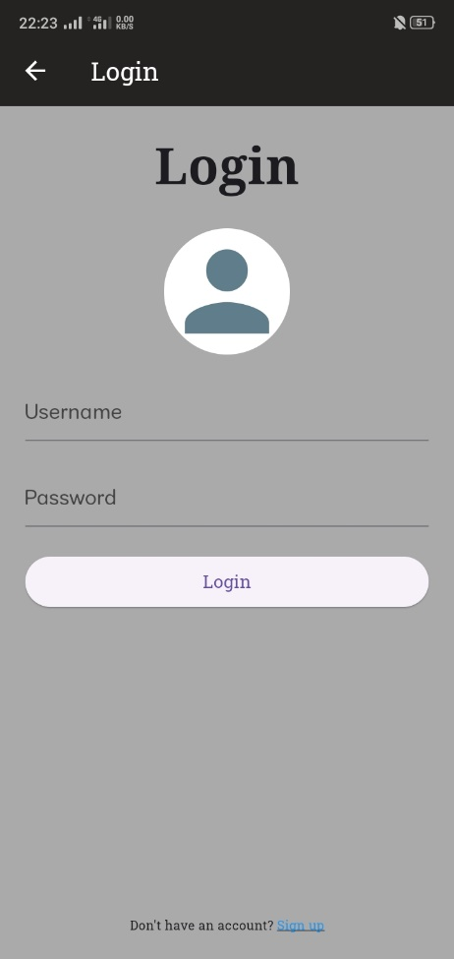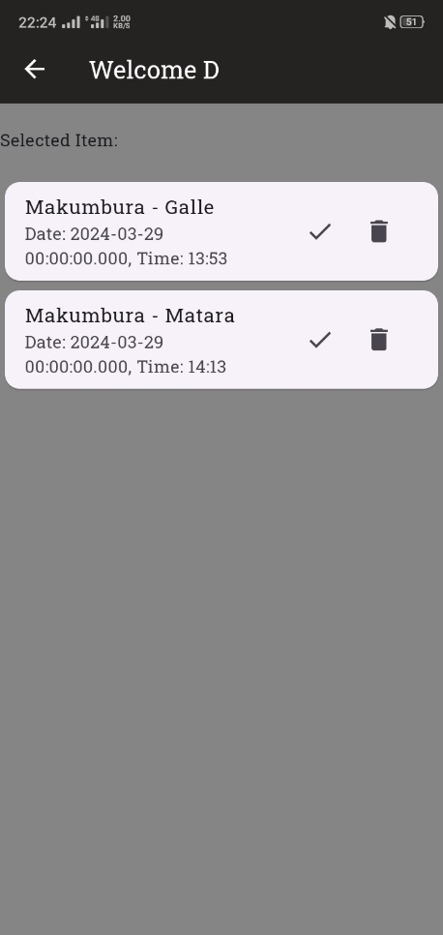

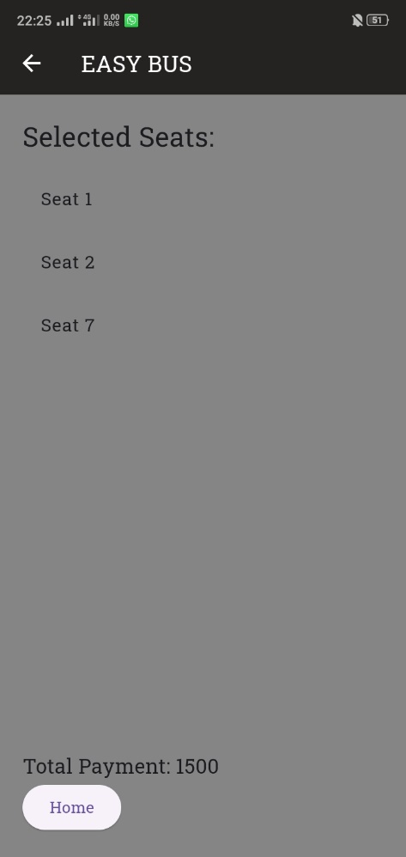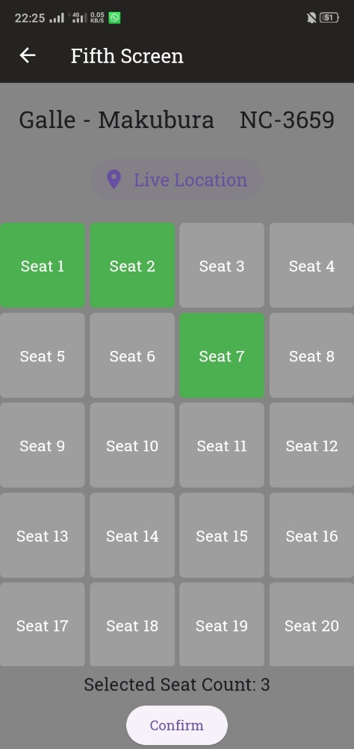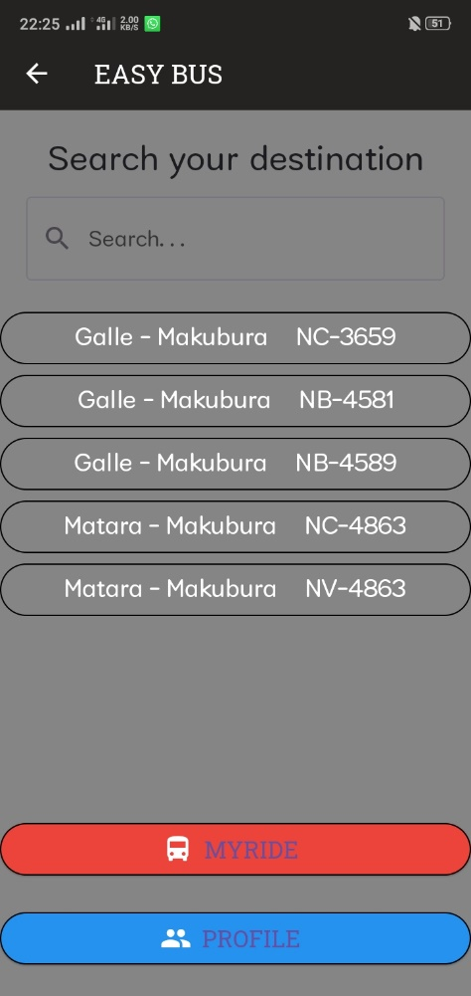

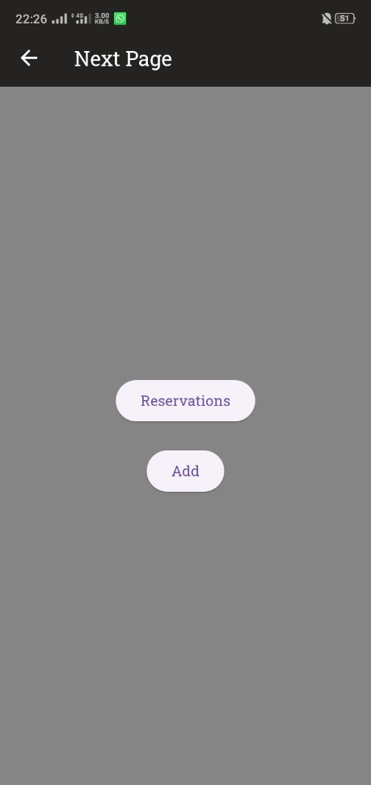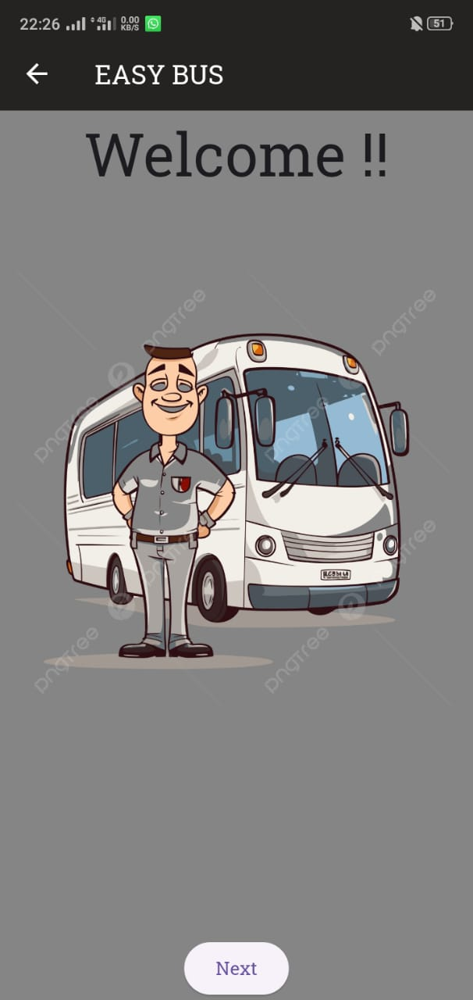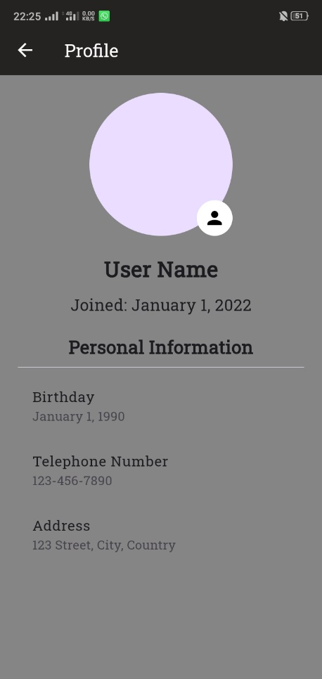

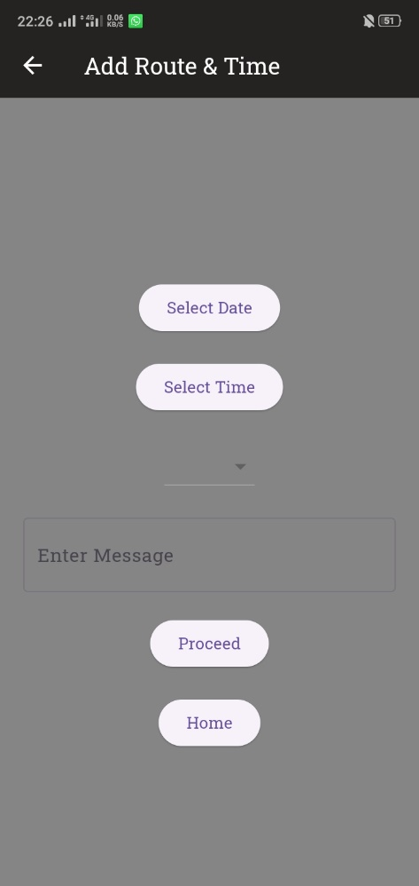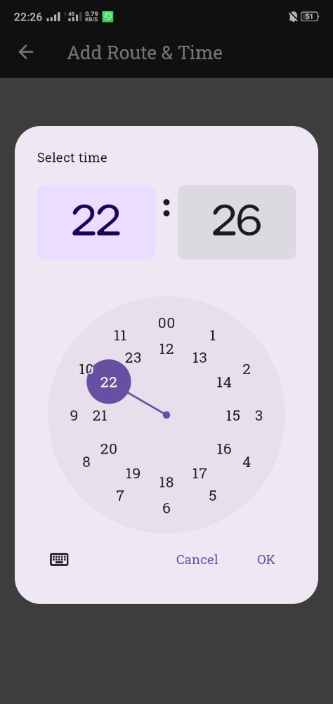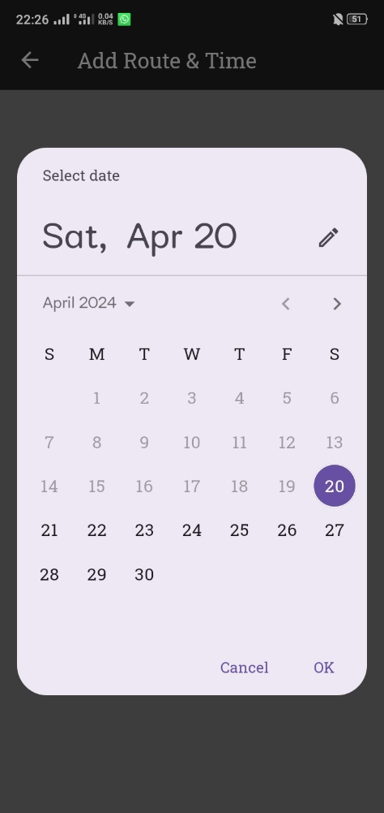

## Firebase Firestore Database Tables

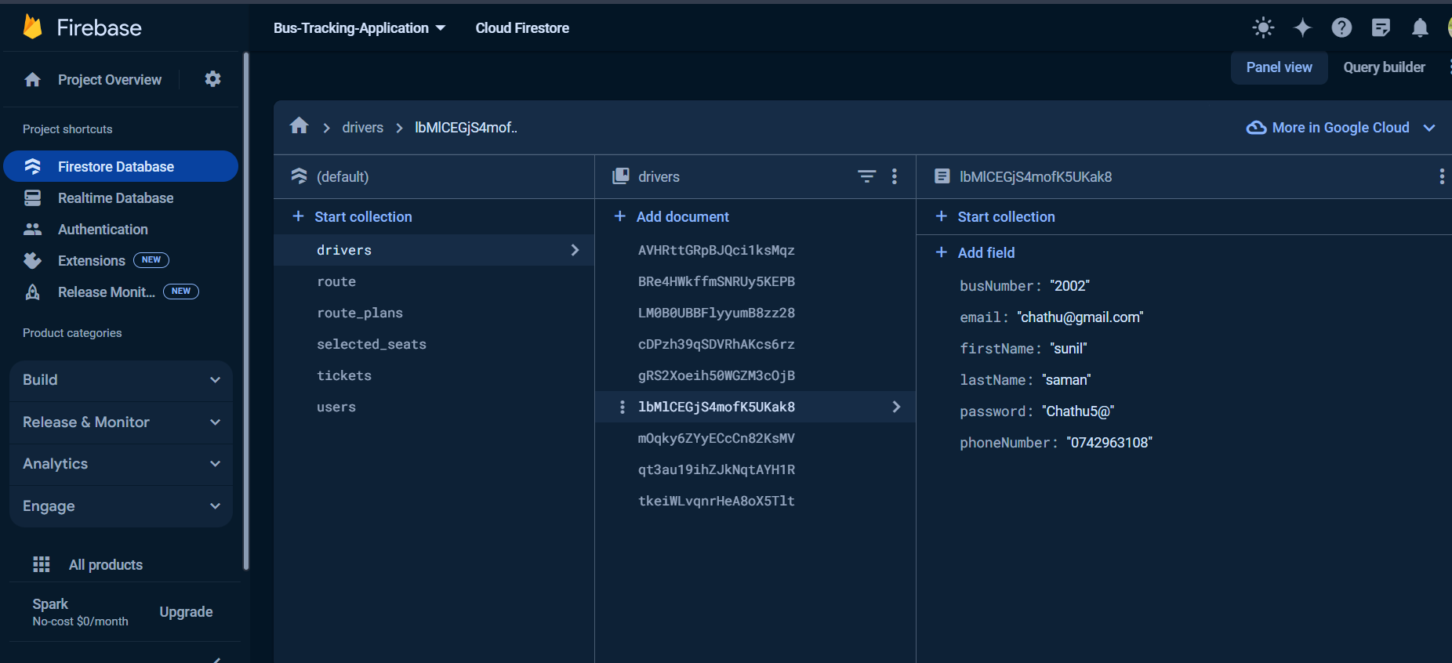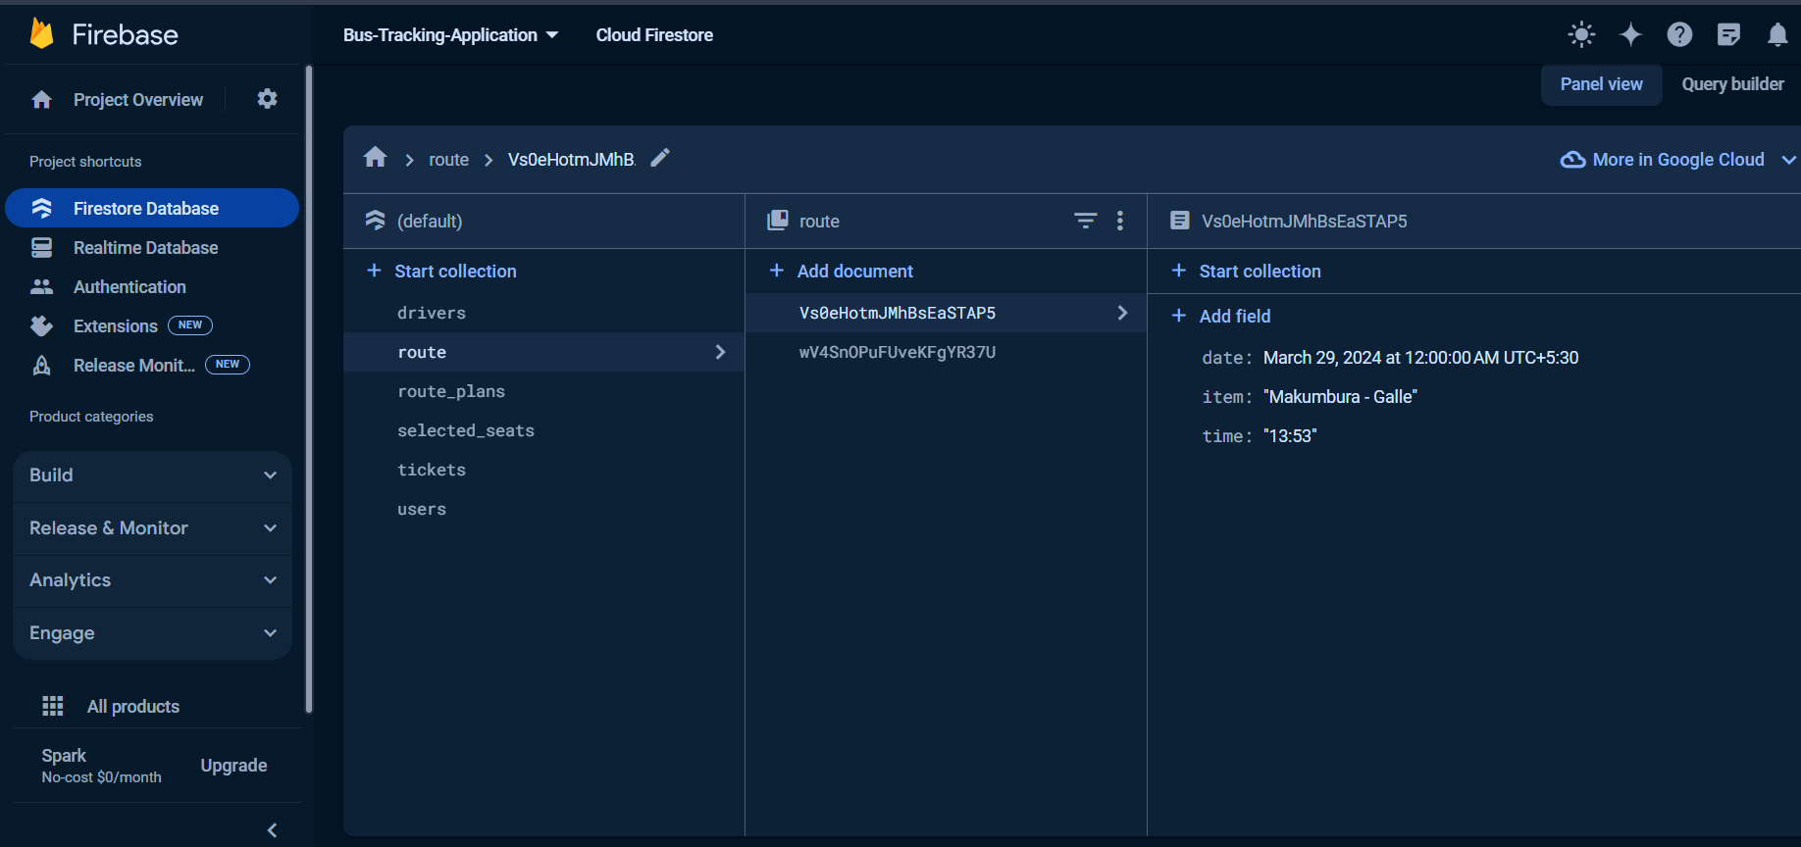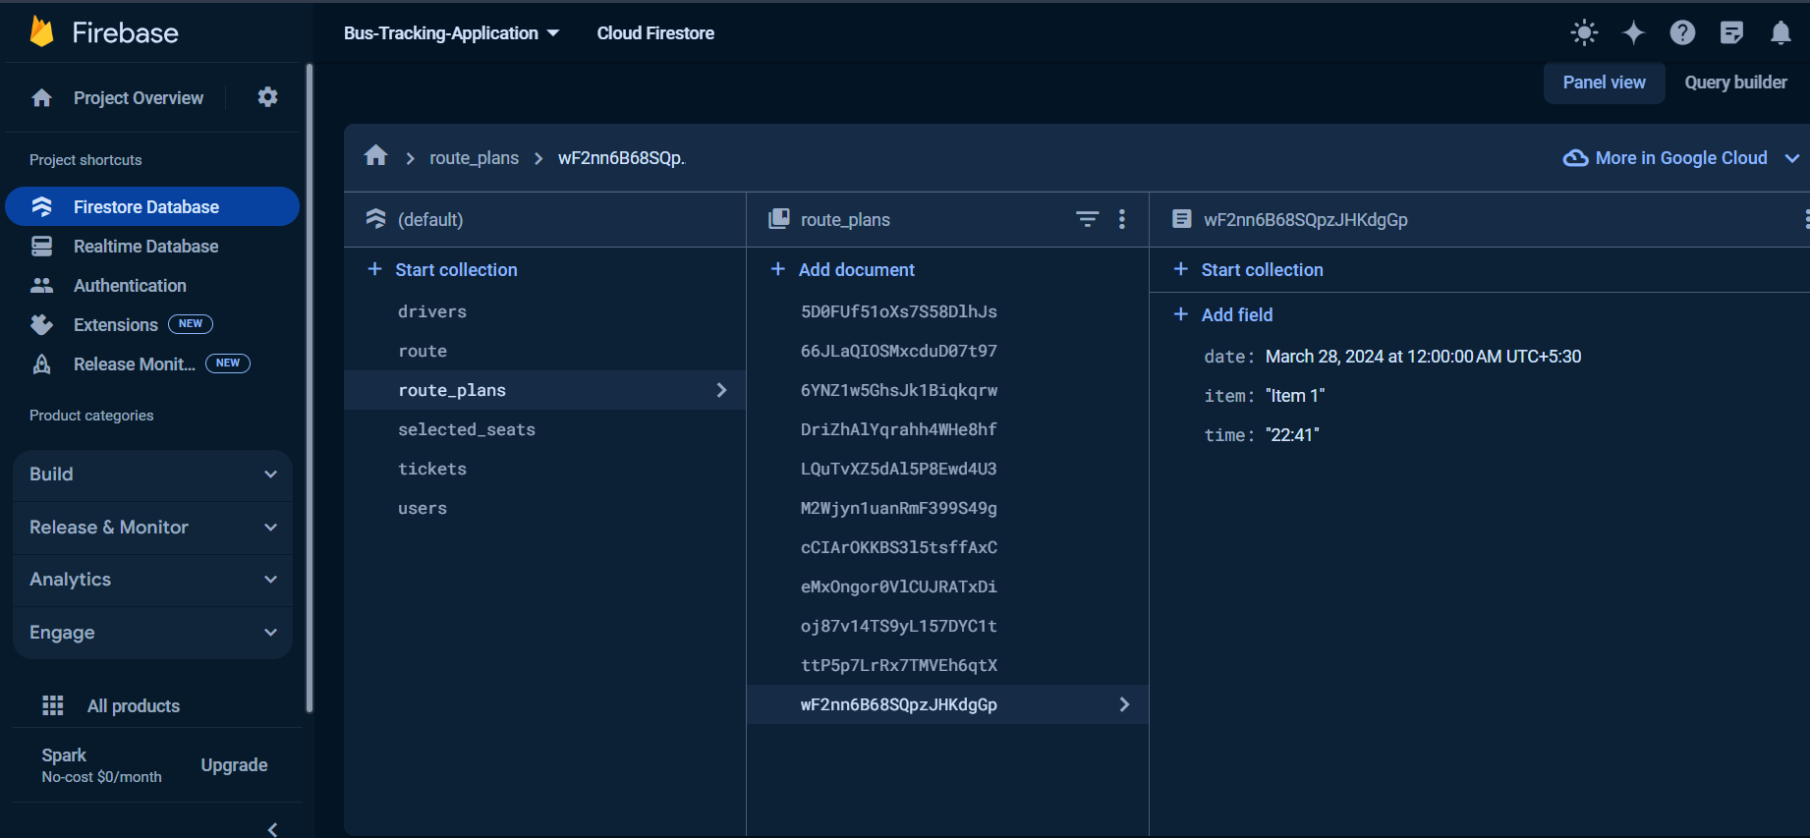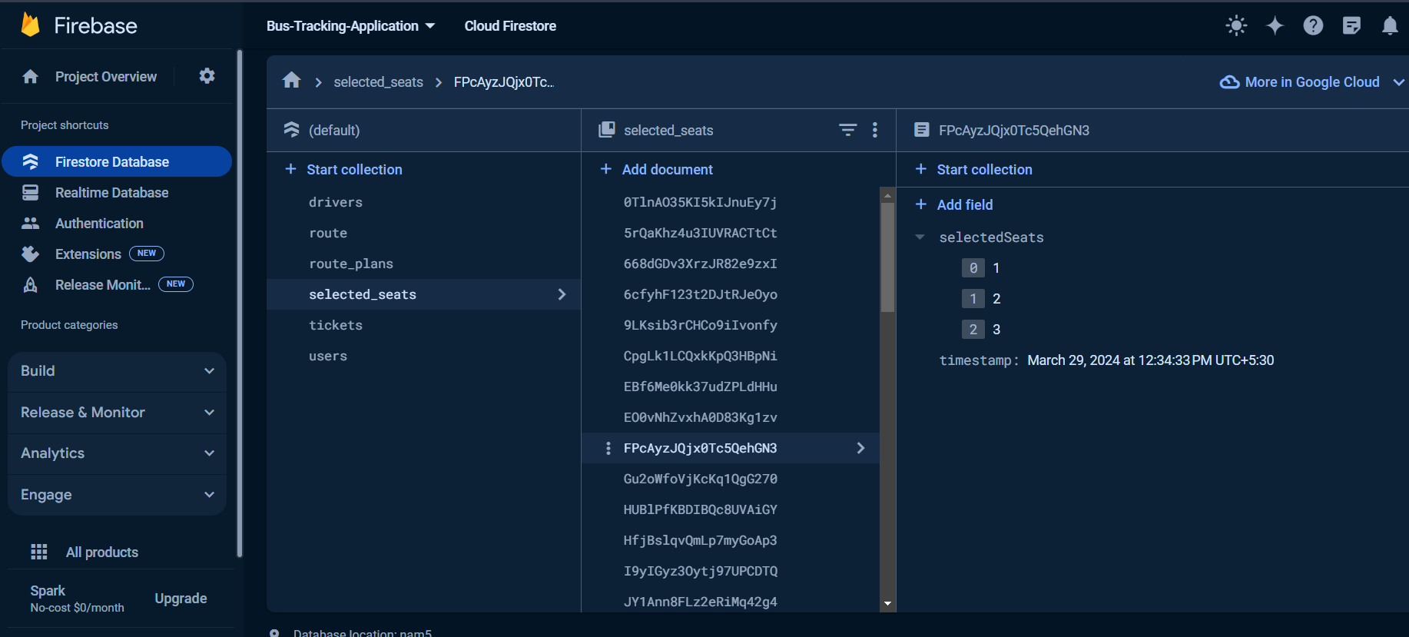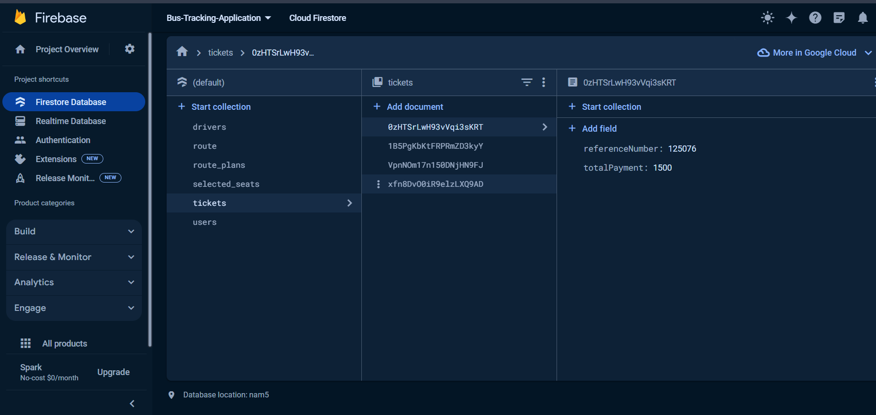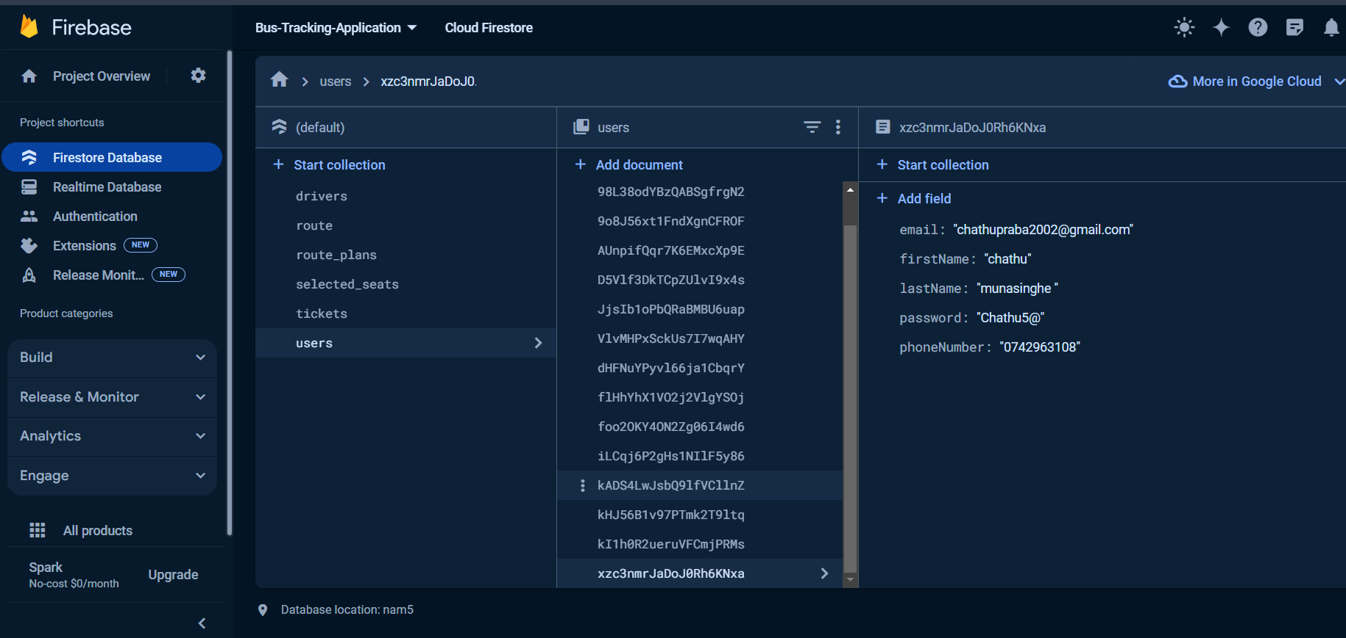

## Data Model

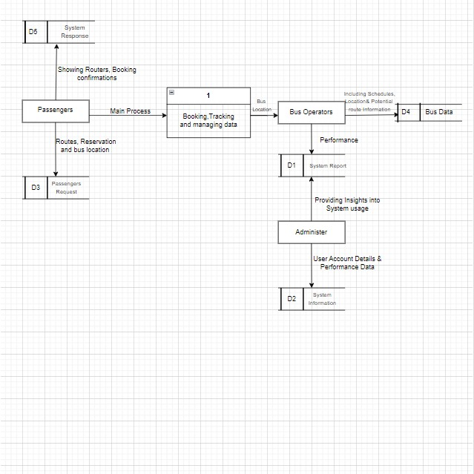

## System Architecture

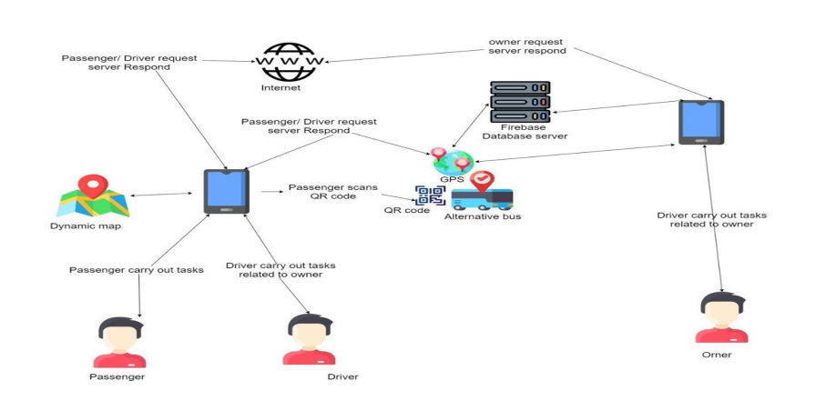

## Deployment and Infrastructure

The distribution strategy called for the mobile application to be uploaded to app stores in order to be made available to users. Hosting any backend services required for the application was part of the infrastructure's scalability and reliability. If Flutter and Dart development had been involved, this may have meant releasing to marketplaces like the Google Play Store for Android and the Apple App Store for iOS.

## Testing Strategy

1. Unit testing: Create tests for the discrete, tiny parts of your code, such functions or methods, to ensure that it is operating as intended.   
 o Confirm that each and every part of your code performs as intended.  
  
  
2. Integration testing: Verify that all of your system's components are compatible with one another.   
 o Verify that components like databases, external services, and APIs are compatible with one another.   
 o Verify that data flows through the various parts of your system in the correct sequence.

3. Functional testing: Evaluate how well the system performs in relation to the given parameters.

* Verify that users can do other essential tasks, such adding goods, adjusting amounts, and generating reports.
* Confirm that the system operates as expected for different user

## Dependencies

1. Flutter SDK Synopsis:

The Flutter SDK is a prerequisite for developing cross-platform mobile applications with the Dart programming language.  
Its objective is to provide a set of tools and a framework for developing user interfaces to developers and app logic managers.  
  
Take flutter_sdk, for example: ~2.10.0

1. Overview of the HTTP Requests Library: Description: With the help of this library, Flutter applications may make HTTP requests to web services.  
   Its function is to make data retrieval and transmission interactions with backend APIs easier.  
   As an example: ~0.14.0
2. Overview of the UI Component Library:  
   Description: Pre-made widgets and components for interface design are available through user interface component libraries.  
   Purpose: By offering ready-to-use user interface components, they hope to accelerate development.  
   For example: flutter_material: about 0.6.0
3. Opting for Operating Systems:  
   Description: Flutter allows developers to target specific operating systems, such Android and iOS.  
   Goal: By optimizing the software for each platform, it ensures that it has a native look and feel.  
     
   Consider flutter build apk.
4. Flutter Google Maps:  
   Description: This Flutter plugin allows you to easily include Google Maps into your Flutter application.  
   The purpose of this application is to enable users to utilize Google Maps functions such as adding marks, showing maps, and listening to map events.  
   For example:Version 2.1.0 of Google Maps Flutter
5. SQLite   
   This is SQLite, a lightweight database engine for Flutter that enables local data storage on the device.   
     
   Goal: It provides a rapid and simple method for doing database operations, such as creating tables, inserting data, querying data, and more.   
   For example: sqflite: about 2.0.0

# Work breakdown.

## Project Phases:

Phase of planning:

* Identify needs, goals, and scope of the project. Perform competition and market study.
* Identify the mobile application's major features and functions.
* Establish user personas and the intended audience.
* Make a project plan that includes a timeframe and work breakdown structure (WBS).

Phase of Design:

* Create mobile application prototypes and wireframes.
* Create interfaces and user experiences (UI/UX) for bus tracking, ticket purchasing, and other functions.
* Finalize the branding components, typography, and color palettes for the visual design.
* Make interactive prototypes and mockups to get feedback and conduct user testing.

Phase of Development:

* Establish the infrastructure and development environment. Deploy front-end development for the mobile application using the relevant frameworks (e.g., Flutter, React Native).
* Create backend services that manage bus tracking, booking transactions, user authentication, and other features.
* Combine external APIs for geolocation, payment processing, and more functions.   
  To track and update buses, use real-time communication.
* As the development process progresses, carry out integration and unit testing.   
  Phase of Testing: Carry out extensive testing, encompassing functional, usability, performance, and security assessments of the mobile application.
* Determine and fix mistakes, defects, and performance problems.
* Get input for future developments from stakeholders and beta testers.
* Achieve adherence to the rules set forth by mobile platforms (like Google Play and the App Store).

Phase of Deployment:

* Get ready to submit your software to the app store by making screenshots, descriptions, and marketing materials.
* Prepare the mobile application for iOS and Android devices.
* Upload the program to the appropriate app stores (Google Play Store, Apple App Store).   
  Keep an eye on the deployment procedure and handle any problems or denials from app store review teams.
* Organize app launch marketing and promotion activities.

Phase of Maintenance and Support: ¬

* Track app usage and user input after launch.
* Issue updates and bug fixes as needed.
* Answer questions from users and deal with their problems by offering customer assistance.
* Constantly enhance the application by taking into account market trends and customer input.

## Work Breakdown Structure (WBS)

**1. Planning Phase**

1.1- Define project scope and objectives

1.2- Conduct market research

1.3- Identify key features and requirements

1.4- Create project plan and timeline

**2. Design Phase**

2.1- Develop wireframes and prototypes

2.2- Design UI/UX

2.3- Create visual design elements

2.4- Finalize mockups and prototypes

**3. Development Phase**

3.1- Set up development environment

3.2- Front-end development

3.3- Back-end development

3.4- API integration

3.5- Real-time communication implementation

**4. Testing Phase**

4.1- Functional testing

4.2- Usability testing

4.3- Performance testing

4.4- Security testing

**5. Deployment Phase**

5.1- Prepare for app store submission

5.2- Package and submit the application

5.3- Monitor deployment process

5.4- coordinate with marketing efforts

**6. Maintenance and Support Phase**

6.1- Monitor app performance

6.2- Release updates and bug fixes

6.3- Provide customer support

## Timeline:

Planning Phase: 4 weeks

Design Phase: 6 weeks.

Development Phase: 10 weeks

Testing Phase: 3 weeks

Deployment Phase: 3 weeks

Maintenance and Support Phase: Ongoing

## Gnatt chart

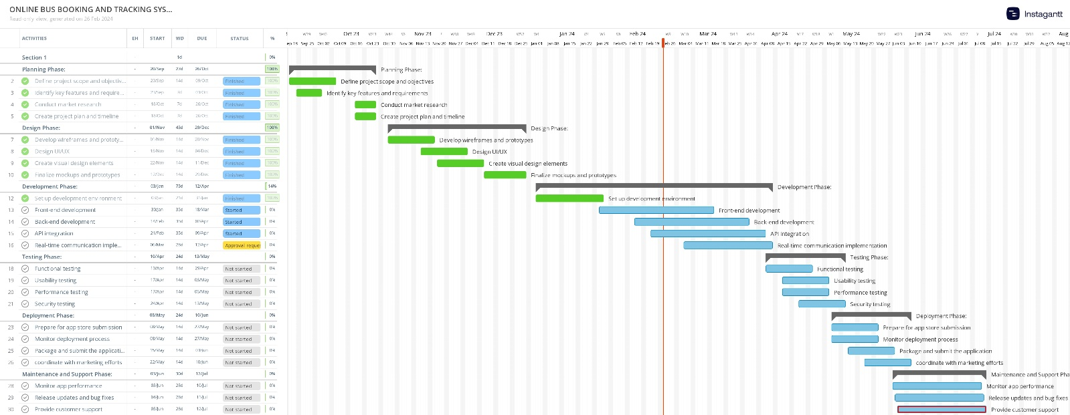

## Critical Path & total time duration.

Project Kickoff -> Market Research -> Feature Definition -> Design and Prototyping -> Front-end Development -> Back-end Development -> Real-time Communication Implementation -> Testing Phase -> Deployment Readiness -> Launch -> Maintenance and Support

## The total time duration for completing the critical path tasks is:

4+6+10+3+3 = 26 weeks Maintenance and Support Phase: Ongoing

## Resource Allocation

|  |  |
| --- | --- |
| 1.1- Define project scope and objectives | Badal Gamage  Wedamulla Madusanka  Yaddehi Kishal Sankalpa  Kihaduwage Sahasra  Senanayake Liyanage  Chathupraba Munasinghe |
| 1.2- Conduct market research | Kihaduwage Sahasra  Wedamulla Madusanka |
| 1.3- Identify key features and requirements | Kihaduwage Sahasra  Senanayake Liyanage |
| 1.4- Create project plan and timeline | Badal Gamage  Yaddehi Kishal Sankalpa  Wedamulla Madusanka |
| 2.1- Develop wireframes and prototypes | Wedamulla Madusanka  Yaddehi Kishal Sankalpa  Kihaduwage Sahasra |
| 2.2- Design UI/UX | Yaddehi Kishal Sankalpa  Chathupraba Munasinghe |
| 2.3- Create visual design elements | Wedamulla Madusanka  Senanayake Liyanage  Chathupraba Munasinghe |
| 2.4- Finalize mockups and prototypes | Badal Gamage  Wedamulla Madusanka  Yaddehi Kishal Sankalpa |
| 3.1- Set up development environment | Badal Gamage  Kihaduwage Sahasra  Senanayake Liyanage |
| 3.2- Front-end development | Yaddehi Kishal Sankalpa  Badal Gamage  Wedamulla Madusanka |
| 3.3- Back-end development | Badal Gamage  Yaddehi Kishal Sankalpa  Wedamulla Madusanka |
| 3.4- API integration | Badal Gamage  Yaddehi Kishal Sankalpa  Wedamulla Madusanka |
| 3.5- Real-time communication implementation | Kihaduwage Sahasra  Senanayake Liyanage  Chathupraba Munasinghe |
| 4.1- Functional testing | Kihaduwage Sahasra  Senanayake Liyanage  Chathupraba Munasinghe |
| 4.2- Usability testing | Kihaduwage Sahasra  Senanayake Liyanage  Chathupraba Munasinghe |
| 4.3- Performance testing | Badal Gamage  Yaddehi Kishal Sankalpa  Wedamulla Madusanka |
| 4.4- Security testing | Badal Gamage  Yaddehi Kishal Sankalpa  Wedamulla Madusanka |
| 5.1- Prepare for app store submission | Kihaduwage Sahasra  Senanayake Liyanage  Chathupraba Munasinghe |
| 5.2- Package and submit the application | Badal Gamage  Yaddehi Kishal Sankalpa  Wedamulla Madusanka |
| 5.3- Monitor deployment process | Kihaduwage Sahasra  Senanayake Liyanage  Chathupraba Munasinghe |
| 5.4- coordinate with marketing efforts | Badal Gamage  Yaddehi Kishal Sankalpa  Wedamulla Madusanka |
| 6.1- Monitor app performance | Badal Gamage  Yaddehi Kishal Sankalpa  Wedamulla Madusanka |
| 6.2- Release updates and bug fixes | Badal Gamage  Yaddehi Kishal Sankalpa  Wedamulla Madusanka |
| 6.3- Provide customer support | Kihaduwage Sahasra  Senanayake Liyanage  Chathupraba Munasinghe |

## Milestones alien with deliverables.

1. Project kickoff milestone:

Deliverables: A preliminary timetable, a scoping paper, and the project's objectives.   
Description: Goals, objectives, and preliminary planning are established as part of the project's official start.

1. Features definition milestone:

Deliverables: a feature list, a requirements document, and user stories.   
Determining and documenting the attributes and requirements required for the application.

1. Design and prototyping milestone:

Deliverables: consist of visual elements, wireframes, prototypes, and UI/UX designs.   
Prototyping and visualizing an application to aid with its layout, flow, and functionality visualization is the approach described here.

1. Development kickoff milestone:

Deliverable: A development environment with a completed technology stack.   
Official beginning of the development phase, which entails setting up the infrastructure and necessary instruments.

1. Testing phase milestone:

Deliverables: test plans, test cases, and bug reports.   
 The phase of testing has commenced and encompasses functional, usability, performance, and security testing.

1. Deployment Readiness Milestone:

Deliverable: A working deployment strategy and an application.   
Description: The application is deemed ready for deployment upon satisfactory completion of testing and last-minute preparations.

1. Launch milestone:

Deliverable: The release of the application in app stores and promotional materials.   
Description: Marketing and promotional activities will be conducted in conjunction with the official public release of the application.

1. Post launch evaluation milestone:

Deliverables: User input, performance data, and post-launch analysis.   
This report evaluates the application's functionality and user feedback following its introduction and offers suggestions for further improvements.

# Results and Discussion

## Discussion on Achievements

Throughout the development process, our team successfully conquered the challenge of modernizing Sri Lanka's bus seat reservation and tracking systems. With the use of cutting-edge technology and innovative design principles, we have developed a mobile application that goes above and beyond the expectations of its users. The creation of an easy-to-use user interface that facilitates route searches, bus location tracking, and seat reservations is our greatest achievement. Because of this design's intuitiveness, both bus operators and commuters may experience a smooth and trouble-free experience.  
In addition, the integration of real-time bus monitoring and seat reservation functionalities represents a significant breakthrough in augmenting operational efficiency within the transportation sector.

By providing users with access to current information and enabling quick, secure reservations, our software not only helps bus operators manage resources and enhance service performance, but it also helps customers plan their travels more effectively.

## Test Cases/Test Results Summary

We meticulously prepared and executed a large number of test cases to ensure that our application's functionality and performance were confirmed via our rigorous testing procedure. Methodical testing was used to assess the system's reliability and robustness under a variety of scenarios. According to the test results, the program's main features were determined to be working as planned, and there weren't many obvious flaws. Performance testing confirmed the application's stability and responsiveness, demonstrating reasonable response times and consistent behavior under typical use conditions. Notwithstanding a few minor issues that came out during testing—for instance, errors in the real-time bus tracking data—they were rapidly fixed by little improvements and optimizations.

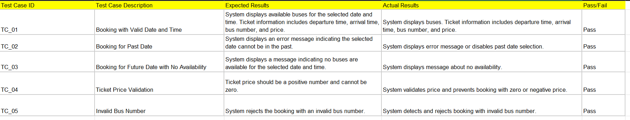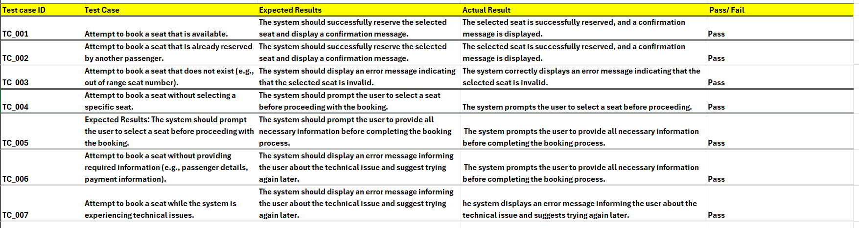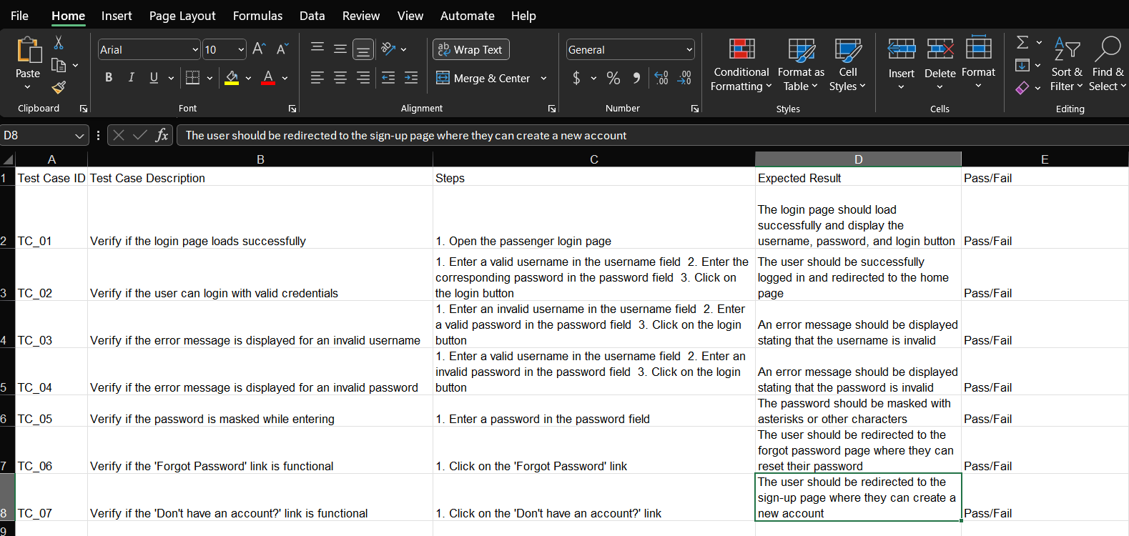

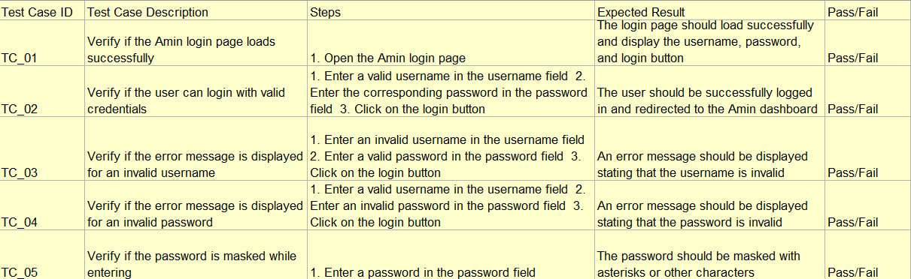

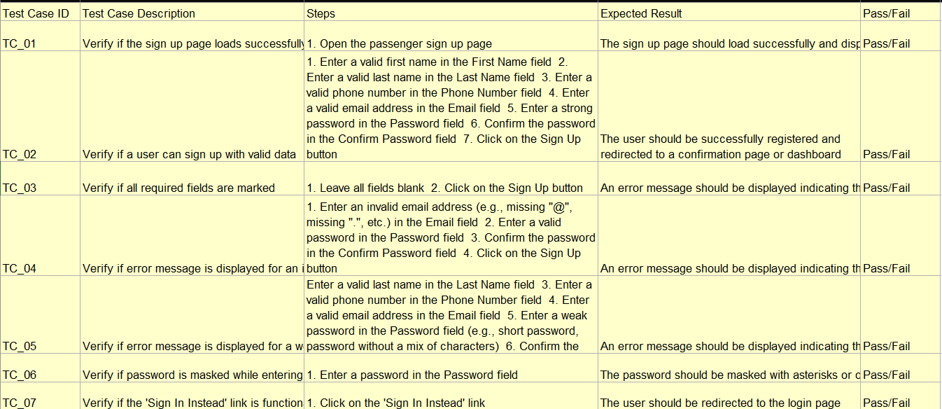

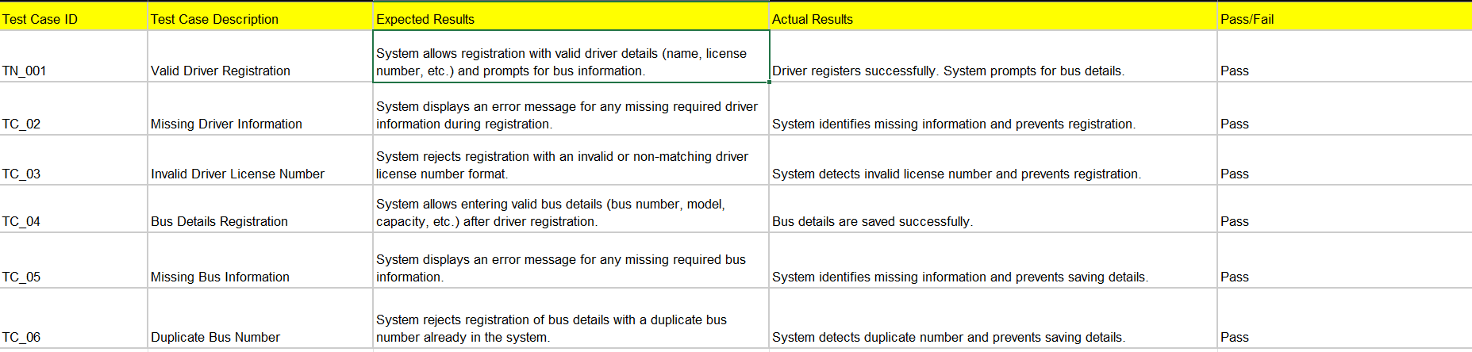

## Findings and rectifications suggested /applied

* Throughout the whole development process, active user input collection and integration took place.
* Stakeholder participation and usability testing sessions were used to collect feedback.
* One area identified for improvement was data synchronization optimization for real-time bus tracking.
* To enhance user comprehension and navigation, usability problems with certain UI elements were fixed.
* The results of the feedback sessions served as the basis for an iterative development process.
* Issues were fixed promptly, and the software was updated often.
* Meeting the evolving needs and expectations of users was the aim of development.

## Future improvements and development path

* Subsequent research endeavors will primarily focus on executing predictive analytical algorithms for the purpose of estimating bus arrival times by utilizing past data and present traffic conditions.
* Security procedures that safeguard user data and payment information will be reinforced in order to boost user confidence and trust.
* The application's feature set will be expanded with the addition of new services including loyalty programs, bus ticket discounts, and interactivity with other forms of transportation for seamless multi-modal excursions.
* Our continuous innovation and development is the foundation of our commitment to delivering an exceptional customer experience and encouraging positive change in Sri Lanka's transportation environment.
* Furthermore, we are currently working on an IoT tracking device project that will include bus tracking functionality once it is completed. As a consequence, users will get significantly more accuracy and dependability in real-time bus tracking.
* The aim is to broaden the scope of the service to encompass all buses in the country, enabling patrons to look up and book tickets for any bus route. Upon the implementation of an extensive reservation system, patrons will have the convenience of reserving seats on numerous bus routes through a unified platform.
* In order to provide broad coverage and ticket availability for a range of places, we will work to link with bus operators around the nation.
* To give customers a simple and efficient booking experience, upgrades such as fare comparison, route planning, and real-time updates will be added.

# Appendix

## Individual contribution Metrix

|  |  |  |
| --- | --- | --- |
| Plymouth ID | Name (as appeared in DLE) | Contributed Section |
| 10899521 | Badal Gamage | 1.1- Define project scope and objectives  1.4- Create project plan and timeline  2.4- Finalize mockups and prototypes  3.1- Set up development environment  3.2- Front-end development  3.3- Back-end development  3.4- API integration  4.3- Performance testing  4.4- Security testing  5.2- Package and submit the application  5.4- coordinate with marketing efforts  6.1- Monitor app performance |
| 10899603 | Wedamulla Madusanka | Gather information from team members and develop and finalize the final project report  1.1- Define project scope and objectives  1.2- Conduct market research  1.4- Create project plan and timeline  2.1- Develop wireframes and prototypes  2.3- Create visual design elements  2.4- Finalize mockups and prototypes  3.2- Front-end development  3.3- Back-end development  3.4- API integration  4.3- Performance testing  4.4- Security testing  5.2- Package and submit the application  5.4- coordinate with marketing efforts  6.1- Monitor app performance  6.2- Release updates and bug fixes |
| 10899685 | Kihaduwage Sahasra | 1.1- Define project scope and objectives  1.2- Conduct market research  1.3- Identify key features and requirements  2.1- Develop wireframes and prototypes  3.1- Set up development environment  3.5- Real-time communication implementation  4.1- Functional testing  4.2- Usability testing  5.1- Prepare for app store submission  5.3- Monitor deployment process  6.3- Provide customer support |
| 10899556 | Yaddehi Sankalpa | 1.1- Define project scope and objectives  1.4- Create project plan and timeline  2.1- Develop wireframes and prototypes  2.2- Design UI/UX  2.4- Finalize mockups and prototypes  3.2- Front-end development  3.3- Back-end development  4.3- Performance testing  4.4- Security testing  5.2- Package and submit the application  5.4- coordinate with marketing efforts  6.1- Monitor app performance  6.2- Release updates and bug fixes |
| 10899621 | Chathupraba Munasinghe | 1.1- Define project scope and objectives  2.2- Design UI/UX  2.3- Create visual design elements  3.5- Real-time communication implementation  4.1- Functional testing  4.2- Usability testing  5.1- Prepare for app store submission  5.3- Monitor deployment process  6.3- Provide customer support |
| 10899600 | Senanayake Liyanage | 1.1- Define project scope and objectives  1.3- Identify key features and requirements  2.3- Create visual design elements  3.1- Set up development environment  3.5- Real-time communication implementation  4.1- Functional testing  4.2- Usability testing  5.1- Prepare for app store submission  5.3- Monitor deployment process  6.3- Provide customer support |

## User requirement gathering data

Questionnaire: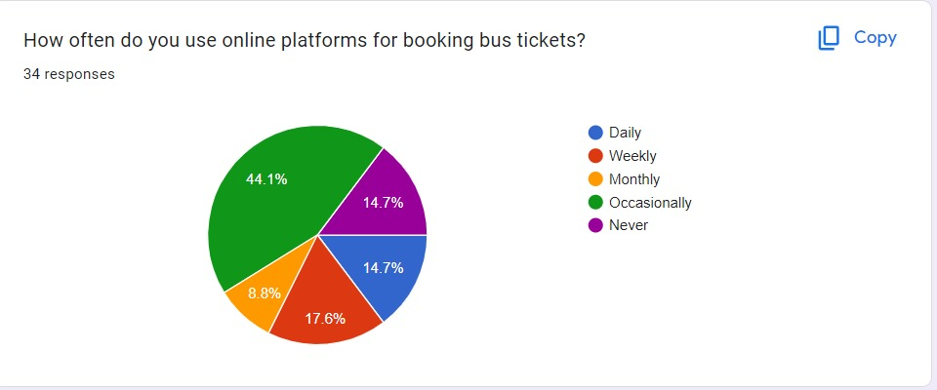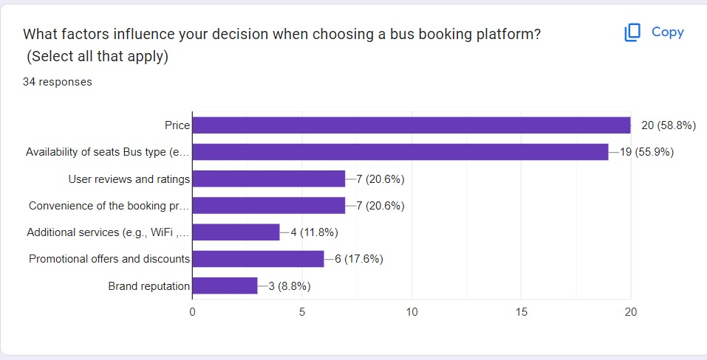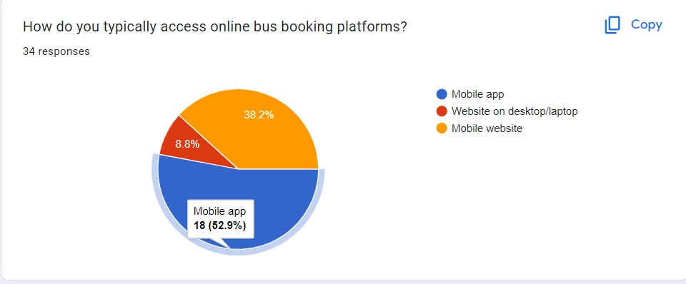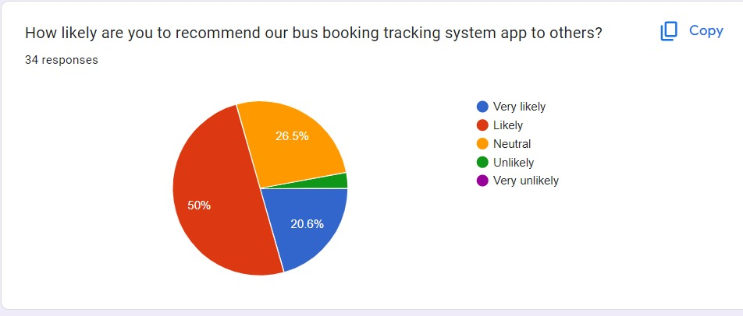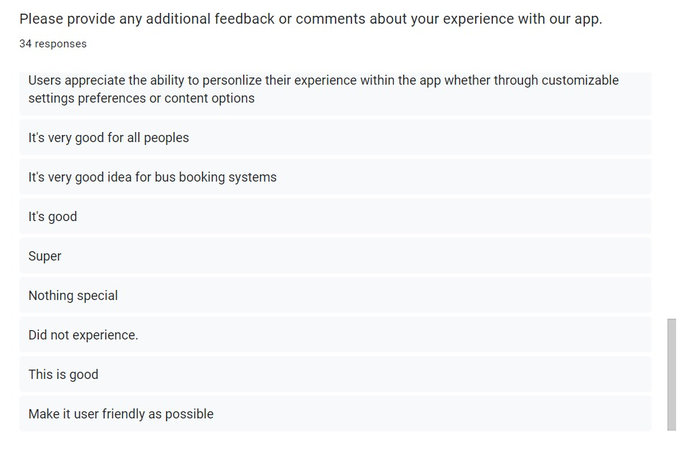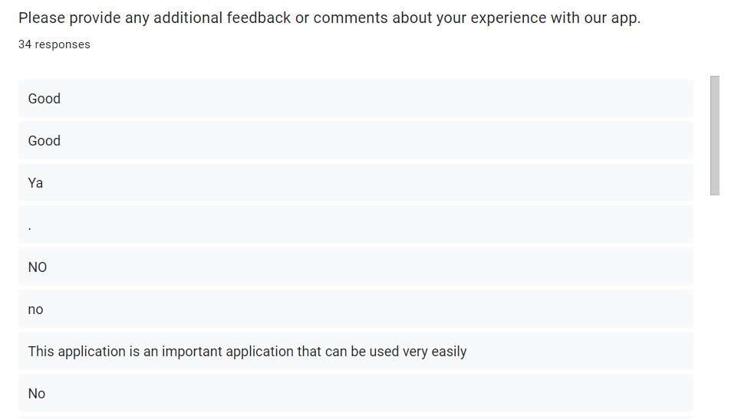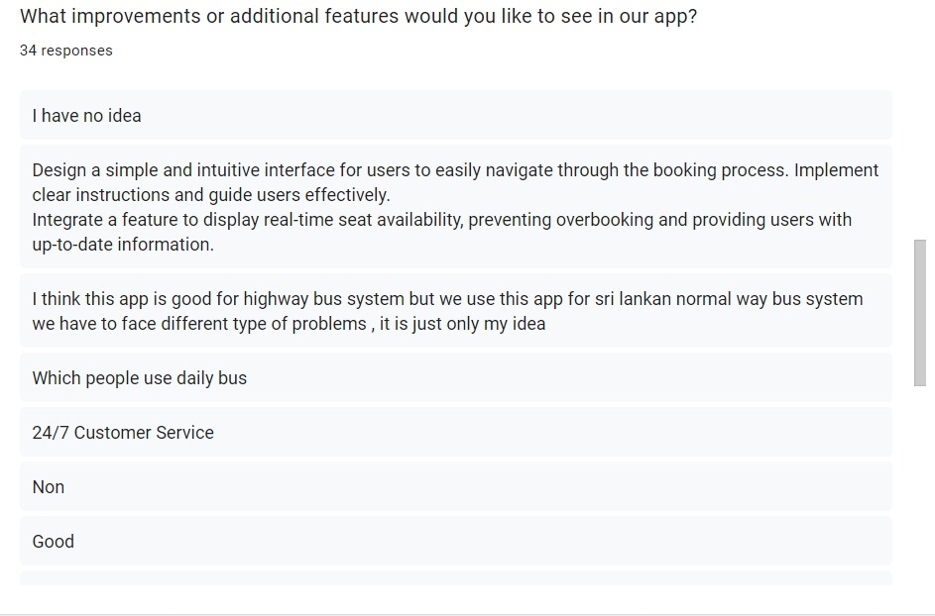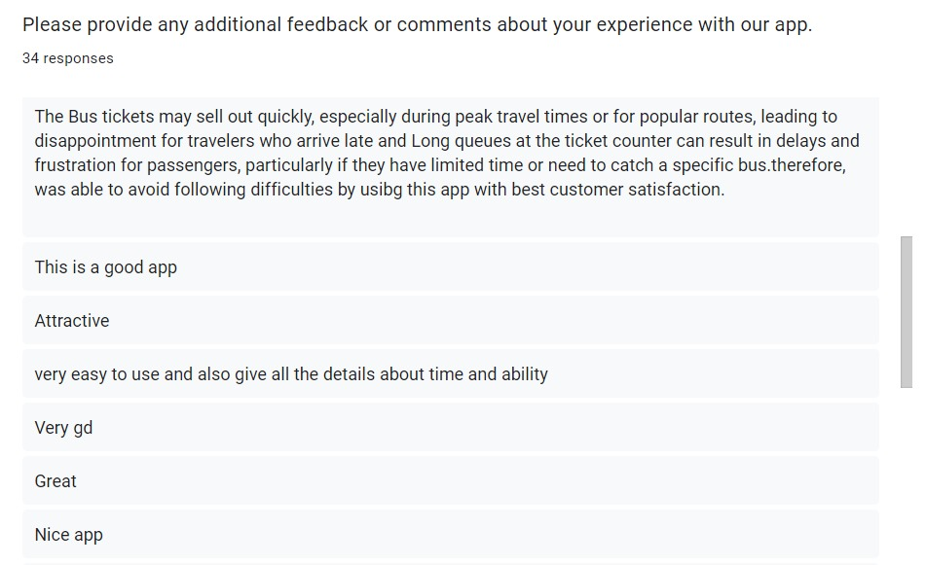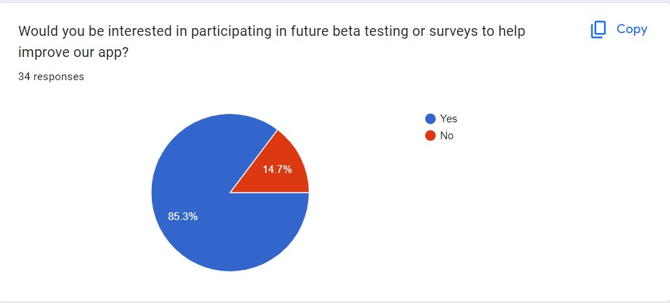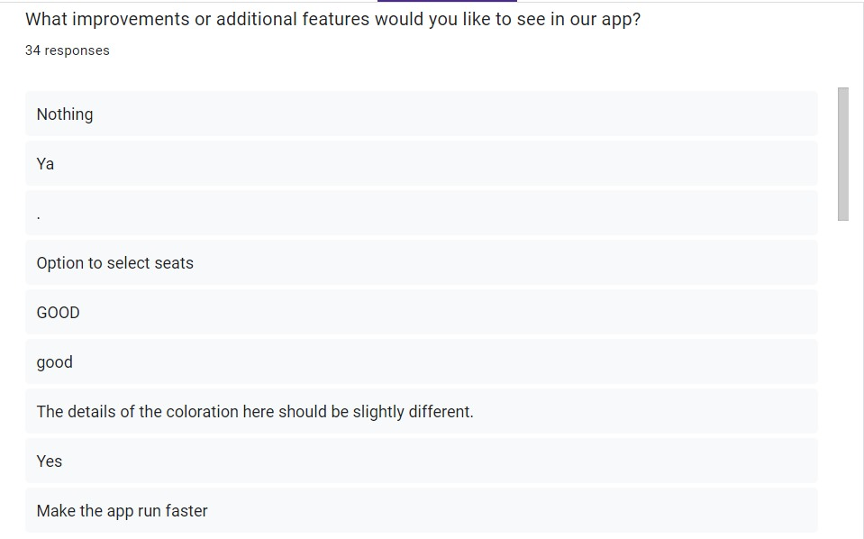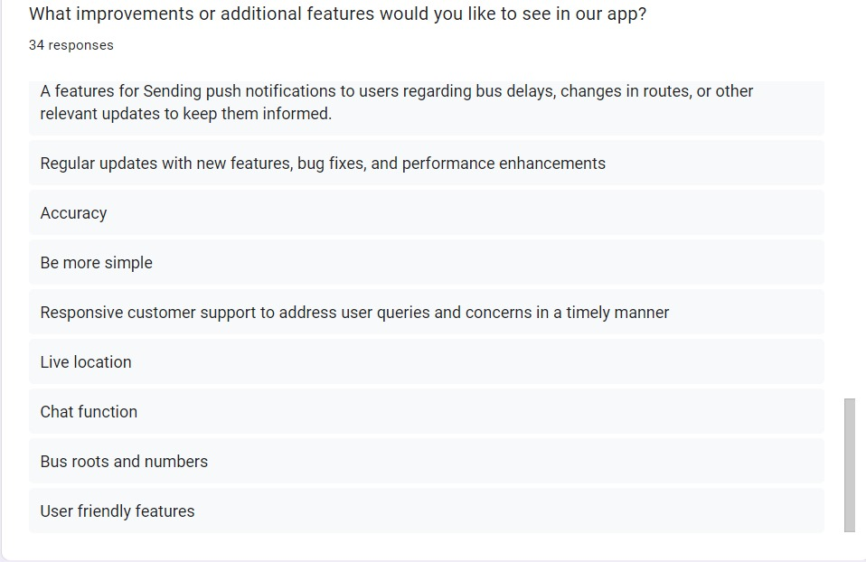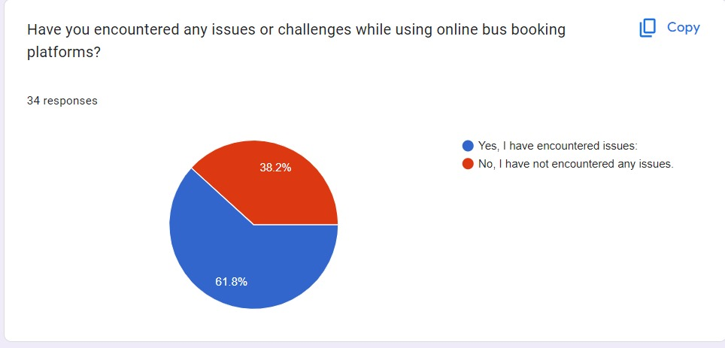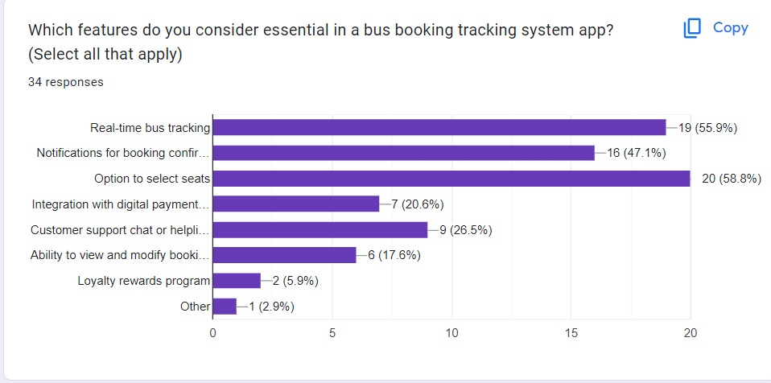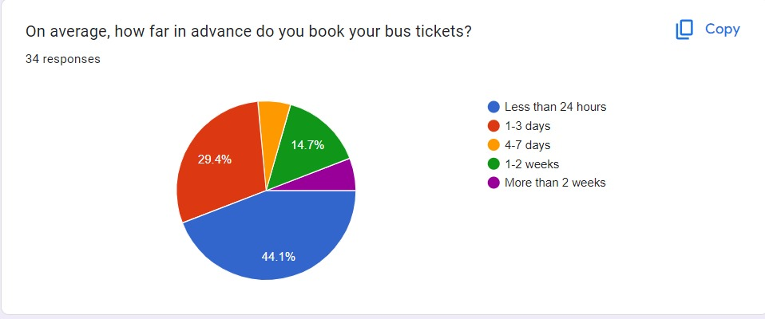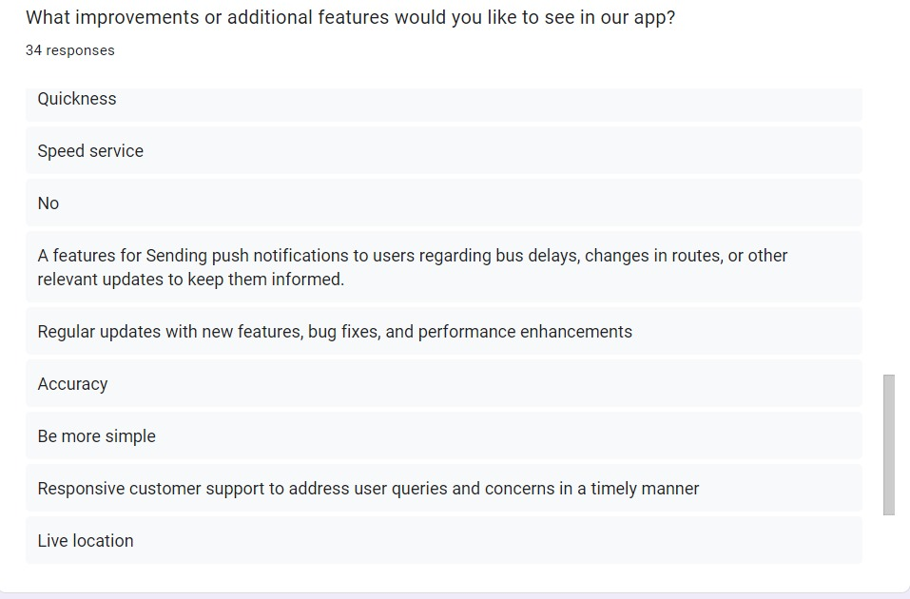

Observation:

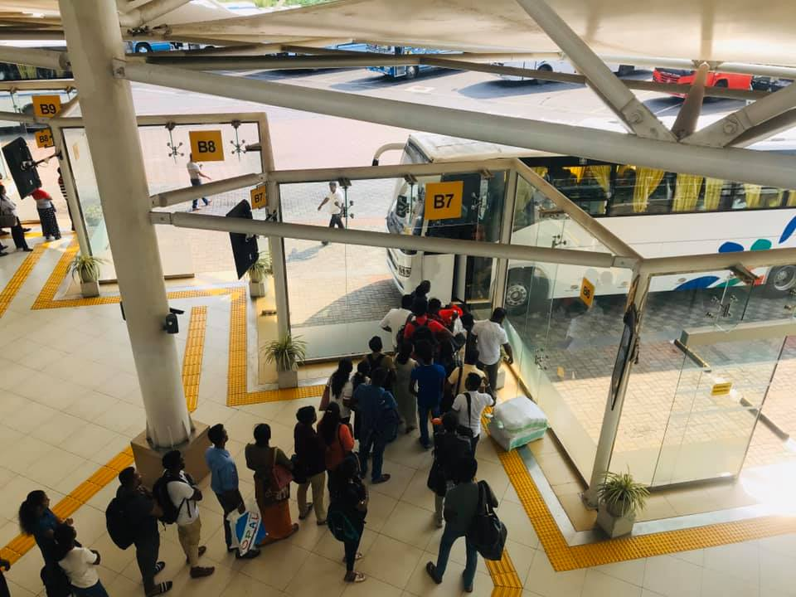

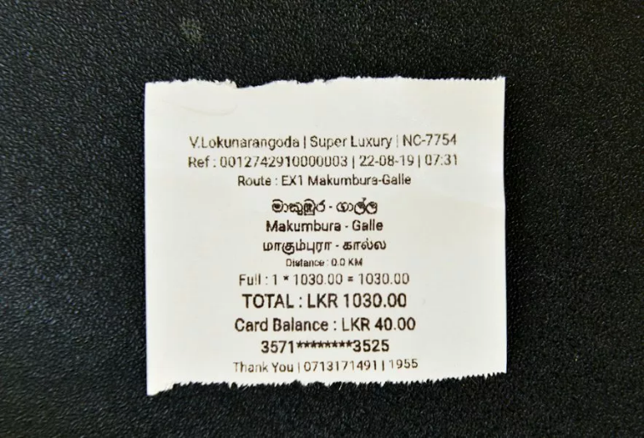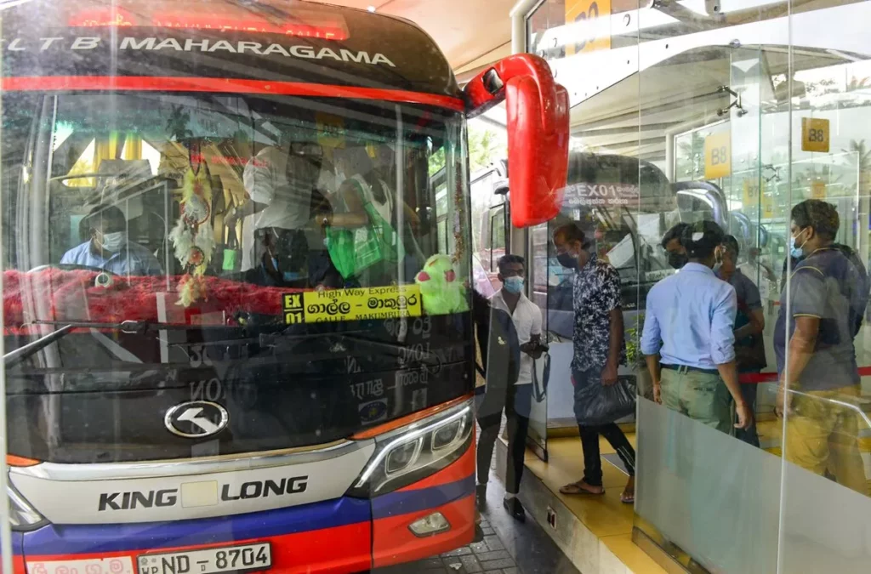

# References

Manners, G., (1965). Book Review: The Expressway And The City By Lewis Mumford, Seeker & Warburg, 1964, Pp. 189, Urban Studies, 2(2)

Nuwan, G., (2020). Reservations. [online] Railway.gov.lk. at: [http://www.railway.gov.lk/web/index.php?option=com_content&view=article&id=61&Itemid=68 &lang=en](http://www.railway.gov.lk/web/index.php?option=com_content&view=article&id=61&Itemid=68%20&lang=en) [Accessed 24 March 2024].

Department of Forestry and Environmental Science, University of Sri Jayewardenepura. (2016). “Proposed Central Expressway Project.”.

*analysis of bus tracking system using GPS on smartphones*. Available at: <https://www.researchgate.net/publication/263582815_Analysis_of_Bus_Tracking_System_Using_GPS_on_Smartphones> (Accessed: 20 April 2024).

*online bus ticket reservation system to the National Transportation Service in Sri Lanka*. Available at: <https://www.researchgate.net/publication/330576072> _ONLINE_BUS_TICKET_RESERVATION_SYSTEM_TO_THE_NATIONAL_TRANSPORTATION_SERVICE_IN_SRI_LANKA (Accessed: 20 April 2024).

# GitHub Link

<https://github.com/thisara02/Bus-Tracking-System.git>

# Conclusion

In conclusion, the development of the seat reservation and tracking system is a significant step toward modernizing Sri Lanka's bus transportation industry. Through the application of state-of-the-art technology, a user-centered approach, and continuous feedback-driven iteration, we have successfully addressed the problem of enhancing user experience and maximizing operational efficiency. Customers may simply book seats, map out their itineraries, and obtain up-to-date bus information on a trustworthy and user-friendly platform by using the smartphone application. The project has been rather successful in its current scope, but there is still a lot of space for expansion and improvement.

By prioritizing user feedback, implementing technological advancements, and encouraging stakeholder involvement, we have established a strong foundation for further positive development and exceptional value delivery to users in Sri Lanka's transportation industry.